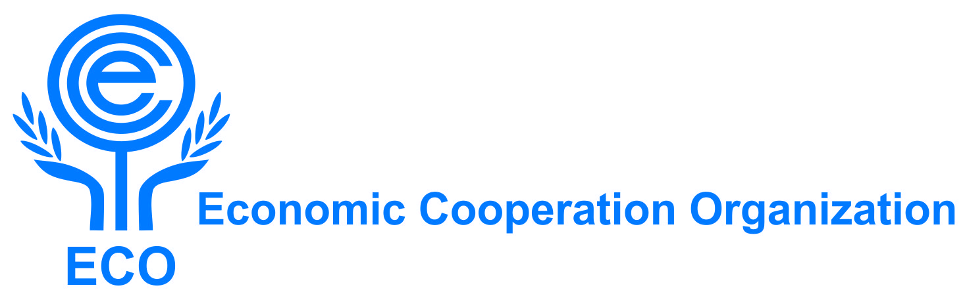

First General Assembly of the State Parties to the ECO Regional Center for Cooperation of Anti-Corruption Agencies and Ombudsmen (RCCACO)

Draft Agenda and
Draft Annotated Agenda

September 21, 2023
The Islamic Republic of Pakistan
(Virtually)

Draft Agenda

- Inauguration of the Meeting
- Election of the Chairman
- Adoption of the Agenda
- Statements/Reports by Heads of Delegation
- Brief presentation about the steps so far taken for establishment of RCCACO
- Exchange of views on the required actions for operationalization of RCCACO
- Consideration of any proposed training/operational activities for the facilitation of RCCACOoperationalization

- Any other business
- Date and venue of the next Meeting
- Closing the Meeting

*****

Annotated Draft Agenda

Agenda Item No.1
Opening of the Meeting

- A senior official from the host country as well as from the ECO Secretariat will make their opening statements.

Agenda Item No.2
Election of the Chairman

- According to the ECO Rules of Procedure, representative of the host country will be elected as the Chairman of the Meeting.

Agenda Item No.3
Adoption of the Agenda

- The Draft Agenda of the Meeting may be considered and adopted.

Agenda Item No.4
Statements/Reports by Heads of Delegation

- Under this agenda item, the Heads of Delegation will be offered opportunity to make statements/presentations as well as to share information about the achievements made in their respective countries, including the potential for enhanced regional cooperation. The suggestions for future cooperation among the Member States may also be put forward.

Agenda Item No.5
Brief presentation about the steps so far taken for establishment of RCCACO
- Under this item, the participants will be given an overview of the efforts so far made for the establishment of RCCACO.
Agenda Item No. 6
Exchange of views on the required actions for operationalization RCCACO
- Under this agenda item, the participants will discuss about necessary actions for early operationalization of RCCACO. The meeting may alsogive tasks to the state parties of RCCACO to prepare the necessary documents in this regard.

Agenda Item No. 7
Consideration of any proposed training/operational activities for the facilitation of RCCACOoperationalization

- The process of operationalization ofRCCACO may be facilitated and streamlined if interested Member States start operational and training cooperation. The participating countries are expected to offer their readiness to organize/co-organize training programmes as well as other capacities-enhancing activities with a view to creating an enabling environment for a successful operationalization of RCCACO. It may be recalled that during the 32nd RPC meeting, the Islamic Republic of Iran and the Republic of Türkiye have expressed their readiness to host some training courses on anti corruption issues.

Agenda Item No. 8
Any other business
- The Meeting may consider any relevant issue not covered by the Agenda.

Agenda Item No. 9
Date and venue of the next Meeting

- Under this agenda item, date and venue of the next meeting will be considered/decided.

Agenda Item No. 9
Closing the Meeting
- The Chairman and any interested Member States may then deliver closing remarks.
*********

