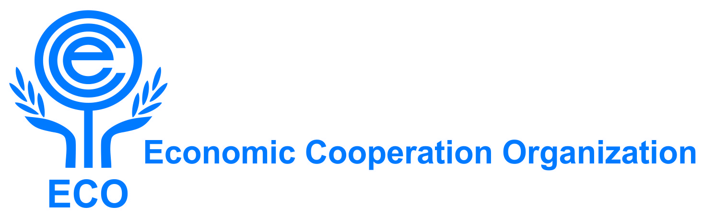

DRAFT ROADMAP
for the
ECO High-Level Dialogue Platform on Environmental Cooperation (HLDPE)

Purpose: To illustrate a modality and practical functioning of the HLDPE, including its frequency, thematic priorities, chairmanship rotation, and linkages with the ECO decision-making process, as discussed during the first HLDPE meeting in Astana on 23 April 2026.

1. Frequency

- The HLDPE shall convene at least one in-person or hybrid meeting per year.
- Virtual thematic sessions (90-120 minutes) may be organized between annual meetings to maintain continuity and advance technical discussions.
- Working language: English.

2. Chairmanship Rotation

- The chairmanship of the HLDPE shall rotate annually among ECO Member State in alphabetical order.
- The Republic of Uzbekistan serves as the first Chair of the HLDPE.
- The Chair, with Secretariat support, will set the agenda, moderate meetings, and prepare a Chair’s Summary reflecting the discussions and key outcomes.

3. Thematic Focus (Refined based on the first HLDPE outcomes)

Member States confirmed the following priority thematic areas, with air quality and sand/dust storms recognized as the central regional priority:
- Air quality management and sand and dust storms (including development of a regional early warning system and joint monitoring)
- Circular economy / pollution management (plastics, chemicals, waste)
- Land degradation and desertification
- Climate change adaptation and mitigation
- Biodiversity conservation and ecosystem restoration (with special attention to the Aral Sea, Caspian Sea, and mountain systems)
- Sustainable land and water management
- Transboundary afforestation (e.g., "Green Shield of Central Asia") and desert ecosystem management
Each annual meeting may focus on 1 or 2 thematic areas to be decided by Member States by consensus.

4. Proposed Timeline of Sessions

Session | Timeframe | Venue / Modality | Expected Output
1st HLDPE | 23 April 2026 | Astana – Republic of Kazakhstan | Chair’s Summary; identification of roadmap direction and priorities
Virtual thematic session | November 2026 (tbc) | Online | Technical brief on sand and dust storms and air quality monitoring
2nd HLDPE | 2027 (tbd) | To be declared by the next HLDPE chairmanship for 2027 | Identification of pilot cooperation activities (such as clean air consortium model, early warning system)
Virtual thematic session | November 2027 (tbc) | Online | Progress update on pilot activities and data-sharing mechanisms

5. Link to ECO Decision-Making

- HLDPE outcomes shall be formulated as consensus-based, non-binding recommendations.
- Recommendations of the HLDPE shall be transmitted through HLDPE → ECO Working Group on Environment → ECO Ministerial Meeting on Environment.
- The Chair’s Summary shall be circulated to all Member States following each HLDPE meeting.

6. Practical Modalities and Format

- Participation: Governmental authorities, academia, experts, national institutions. Observers such as international organizations and civil society may be invited by the Member States’ consent. Delegation lists shall be submitted to the ECO Secretariat before each meeting.
- National Focal Institutions (NFIs): Each Member State shall designate its National Focal Institution (NFI) to HLDPE. The Chairman and NFIs will play a critical role to ensure that the deliverables are result-oriented, implemented and effectively monitored.
- Thematic Working Groups: To be established as needed (e.g., on sand and dust storms, air quality, afforestation) to move from dialogue to practical cooperation.
- Scientific and innovation cooperation:
  - Leverage existing institutions, including the Research Institute for Combating Desertification and Desert Economy (Tashkent) as a shared platform for research, data exchange, and capacity building.
  - Promote academic exchange, research residencies, and engagement with Green University and international researchers.
- Secretariat role: Coordination, assisting in preparation of summary records, and follow-up.

7. Next Steps

Action | Deadline / Timeline
Secretariat circulates the revised roadmap | May 2026
Submit the final draft roadmap via ECO Working Group on Environment to the 6th ECO Ministerial Meeting on Environment for endorsement | By 3 June 2026 (Samarkand)
Call for a host for the 2nd HLDPE (2027) | During (and if necessary after) the 6th ECO Ministerial Meeting on Environment
Confirm thematic focus for 2nd HLDPE based on first meeting outcomes | October 2026
Launch first virtual thematic session (sand and dust storms + air quality) | December 2026
Encourage development of pilot initiatives (for instance Kazakhstan-Uzbekistan clean air consortium model, transboundary afforestation) | Ongoing from 2026 onward

