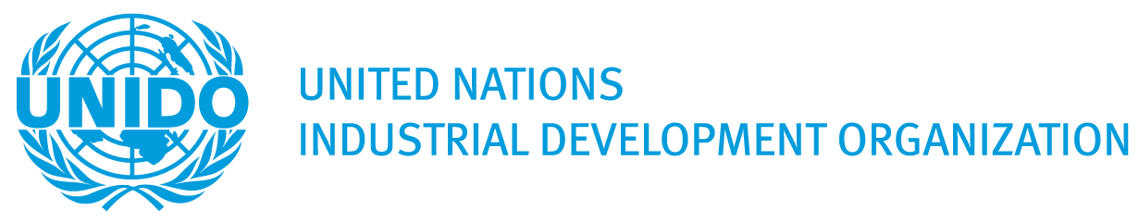
Concept Note: Strategic Foresight for Circular Economy Transition in the ECO Region

Issue Description
The ECO region, comprising ten member states—Afghanistan, Azerbaijan, Iran, Kazakhstan, Kyrgyzstan, Pakistan, Tajikistan, Turkey, Turkmenistan, and Uzbekistan—is facing mounting environmental and economic challenges due to unsustainable resource use. Material extraction and processing contribute significantly to biodiversity loss, water stress, and greenhouse gas emissions. The region’s diverse socio-economic profiles and industrial structures reflect varying degrees of readiness and capacity for circular economy (CE) transition.
Despite these challenges, the circular economy presents a transformative opportunity for the ECO region. It offers pathways to decouple economic growth from resource consumption, reduce environmental degradation, and foster innovation and competitiveness. Recognizing this, the ECO launched the RESCUE Initiative at COP29 in 2024 and requested UNIDO’s support to develop a robust needs assessment and strategic foresight roadmap for CE transition.

UNIDO’s Relevance
UNIDO is uniquely positioned to support the ECO region in this endeavor due to its:
- Proven expertise in strategic foresight methodologies applied to industrial and STI systems.
- Long-standing engagement in circular economy policy development and implementation.
- Capacity to mobilize multi-stakeholder networks and facilitate regional cooperation.
- Experience in gender mainstreaming, ensuring inclusive and equitable development.
UNIDO’s approach integrates participatory foresight with CE strategy formulation, enabling ECO countries to anticipate future challenges, identify key technologies, and co-create actionable roadmaps for sustainable industrial transformation.

Proposed Solution
The objective of the project is to enhance the capacity of stakeholders in ECO countries in developing and implementing policies and strategies for a just and appropriate transition towards circular economy compatible with the economic and social goals of the member countries.

Expected Outcomes
- Adoption of a regional needs assessment and feasibility analysis for CE transition by ECO and member governments.
- Establishment of an operational stakeholder network for CE foresight and implementation across the ECO region.

Outputs and Activities

Output 1: Baseline Study and Preconditions Assessment
- Analyze national and regional CE trends, industrial structures, and stakeholder ecosystems.
- Map existing CE initiatives, policies, and business practices.
- Identify key product value chains and sectors for CE promotion.
- Conduct stakeholder and social network analysis to assess cooperation potential and conflicts.
- Develop circularity indicators and economic metrics for prioritized sectors.

Output 2: National Foresight Exercises and Strategic Recommendations
- Mobilize diverse stakeholder groups (government, academia, industry, civil society).
- Conduct desk research and consultations to build exploratory scenarios.
- Identify and assess key technologies through surveys and expert panels.
- Develop future visions for CE transition at national and value chain levels.
- Formulate technology roadmaps and policy recommendations.

Output 3: Regional Needs Assessment and Supranational Synthesis
- Consolidate national foresight results into a regional synthesis.
- Organize a supranational conference hosted by ECO HQ in Tehran to present findings.
- Prepare a final report with regional CE transition pathways, policy recommendations, and cooperation mechanisms.

Implementation Approach
- Multi-country foresight methodology applied to four representative ECO countries.
- Three foresight horizons: immediate, 2030–2035, and beyond.
- Participatory process involving national implementing partners, foresight experts, CE specialists, and a high-level steering committee.
- Gender mainstreaming integrated throughout all activities.
This project will equip ECO member states with the strategic intelligence, stakeholder engagement mechanisms, and policy tools necessary to lead a just and effective transition to a circular economy. UNIDO’s foresight-driven approach ensures that the transition is not only technically sound but also socially inclusive and regionally coordinated.

INDICATIVE BUDGET

Project Budget Breakdown (US$)

Budget Line | Description | Year 1 | Year 2 | Project Total
11-00 | International experts on technology foresight and circular economy | 65600  (8.2 w/m) | 64800  (8.1 w/m) | 130400  (16.3 w/m)
17-00 | Research clerk | 10000 | 2000 | 12000
15-00 | Project travel costs | 34000 | 25000 | 59000
16-00 | UNIDO staff travel costs | 7500 | 10000 | 17500
Sub-total |  | 117100 | 101800 | 218900
21-01 | Sub-contract 1 – Baseline study contractor | 64800 | - | 64800
21-02 | Sub-contract 2– National Implementing Partners (4) | 72800 | 112000 | 184800
21-02 | Sub-contract 3 – Project terminal evaluation contractor | - | 25000 | 25000
33-00 | Conference, workshops, roundtables, meetings | 50000 | 20000 | 70000
51-00 | Communications, dissemination material, reports editing and printing, mailing, copying, media, translation, interpretation, IT services. | 10500 | 18300 | 28800
Total |  | 315200 | 277100 | 592300
PSC (13%) |  | 40976 | 36024 | 77000
Grand Total |  | 356176 | 313124 | 669300

It is foreseen that ECO countries counterparts will provide preparatory contribution amounting to US$50,000 and provide in-kind staff time and temporary office space for short-term international experts on mission.

