

**CONCEPT NOTE**

**AND**

**DRAFT AGENDA**

**2nd Experts Group Meeting on establishment of the ECO Regional Electricity Market**

**(ECO-REM)**

**27-28November 2024**

**Dushanbe, Tajikistan**

**CONCEPT NOTE**

***Background***

The 1st Experts Group Meeting on establishment of the ECO Regional Electricity Market was held in November 2013 in Tehran (I.R. Iran). The delegates of the Republic of Azerbaijan, Islamic Republic of Iran, Kyrgyz Republic, Islamic Republic of Pakistan, Republic of Tajikistan and Republic of Türkiye, as well as the representatives of the Nord Pool Spot, ECO-CCI and financial organizations as IDB and ECO-TDB participated at the aforementioned meeting. The major outcomes and recommendations of the meeting were as follows:

* The Islamic Republic of Iran proposed to establish an electricity market in the ECO Region as a pilot project with participation of Iran and Türkiye initially. The idea was that other interested ECO Member States might join this electricity market in later stage for maximum benefit of ECO Region;
* Hiring local consultants from Iran and Türkiye under the supervision of an international consultant with a view to prepare the feasibility study for harmonizing and merging the electricity markets with financial and technical support of interested international financial institutions/donors.

The following activities were subsequently undertaken:

The 1st Iran-Turkey Bilateral Meeting on ECO Regional Electricity Market was organized on 25-26 September 2014 in Ankara (Türkiye). The Meeting agreed to continue regular consultations at experts/managerial levels within the existing framework, as well as through new platforms for dialogue to be introduced by the ECO Secretariat.

The 2nd Iran-Turkey Bilateral Meeting on ECO Regional Electricity Market was convened on 10-11 May 2016 in Shiraz (I.R. Iran). The Meeting decided to define criteria and guidelines for hiring three consultants (2 local and one international) for elaborating the Feasibility Study for establishment of ECO REM. Furthermore, it was agreed to get approval of the ECO Council of Permanent Representatives (CPR) for funding the Feasibility Study from the ECO Feasibility and General Purpose Fund (FGPF) with the possibility of Iran and Türkiye to provide additional seed funding for hiring local consultants.

The 3rd Iran-Turkey Bilateral Meeting on ECO Regional Electricity Market was held on 31 May 2021 virtually given the pandemic. The representatives of the Republic of Azerbaijan were also invited to attend taking into account that Azerbaijan maintained power trade with the Islamic Republic of Iran and Republic of Türkiye.

In 2023, the Secretariat started a dialogue with UNESCAP to align ECO-REM with ESCAP’s “Regional Roadmap on Power System Connectivity: Promoting Cross-border Electricity Connectivity for Sustainable Development”. In December 2023, ECO Secretariat circulated among Member States the tentative schedule of activities, to be undertaken in 2024 with the technical and financial support of UNESCAP. The launching event – virtual meeting titled “Programme on Energy Connectivity in Central Asia and the Caucasus” was held on 24 January 2024. The aforementioned virtual kickoff meeting marked the launch of the ESCAP’s Project “Energy connectivity for sustainable development”.

The United Nations Economic and Social Commission for Asia and the Pacific (UN ESCAP), in partnership with the United Nations Economic Commission for Europe (UNECE) organized the “Regional Stakeholder Consultations on Energy Connectivity and Sustainable Energy” on 12-13 June 2024 in Astana, Kazakhstan. The Consultation aimed to seek expert opinion for the implementation of the UNESCAP – UNECE Programme on Energy Connectivity in Central Asia and the Caucasus launched in January 2024. The meeting discussed further actions for the implementation of the ECO-REM project.

The Secretariat circulated among Member States the draft “Regional Roadmap on Power System Connectivity – ECO Regional Electricity Market: promoting cross-border electricity connectivity for sustainable development”, developed by the consultants of the UNESCAP Project “Energy connectivity for sustainable development”.

***Rationale***

In pursuance with to the objectives of ECO Vision 2025 and ECO Strategy for Energy Cooperation 2030, the Member States have decided to enhance cooperation in establishment of a regional power market initiative, most notably increasing power exchanges and a regional balancing market, as well as making the best use of the already existing power exchanges, inviting other initiatives in the region to support the regional electricity market development.

In the ECO region, there are traditional electricity exporting countries and importing countries. Meanwhile, some countries of the region have surpluses of electricity only at certain times of the year (for instance in summer), but the corresponding transmission lines are missing to sell seasonal surpluses to countries in need.

It is widely recognized that the location of the ECO Region at the crossroads between the emerging Eurasian and European electricity markets creates lucrative opportunities for cross-border trade and provides incentives for enhanced transmission network on regional and interregional levels. The ECO Member States are striving for trade opportunities and selectively enhancing physical infrastructure, which eventually facilitates electricity exports and imports.

The pace and dynamics of cross-border trading patterns in ECO Region demonstrate that over the past period of time the ECO Member States have been active in identifying and benefiting from the trading and investment opportunities in the power field on bilateral levels.

Below are the existing interconnections of power systems among the Member States:

* Afghanistan imports electricity from Iran (by 132&20kV), Tajikistan (by 220, 110&10kV), Turkmenistan (by 220, 110&10kV) and Uzbekistan (by 220&10kV) lines.
* Azerbaijan is interconnected with Iran (by 330, 230&132kV) lines for exchange & transit, with Türkiye (by 154&34,5kV) lines for exchange of electricity.
* Iran is interconnected with Afghanistan (by 132&20kV) and Pakistan (by 132&20kV) lines for export, with Türkiye (by 400&154kV) lines for export, with Turkmenistan (by two 230kV) lines for import of electricity.
* Kazakhstan is interconnected with Kyrgyzstan (by 500&220kV) and Uzbekistan (by 500&220kV) lines for exchange & transit of electricity.
* Kyrgyzstan is interconnected with Kazakhstan (by 500&220kV), Uzbekistan (by 500kV) and Tajikistan (by 110&35kV) lines for exchange & transit of electricity.
* Pakistan imports electricity from Iran (by 132&20 kV) lines.
* Tajikistan exports electricity to Afghanistan (by 220, 110&10kV) lines to Uzbekistan (by 500, 220kV) and also interconnected with Kyrgyzstan (by 110&35kV) lines for exchange & transit of electricity.
* Türkiye is interconnected with Azerbaijan (by 154&34,5kV) lines for exchange and with Iran (by 400&154kV) lines for import of electricity.
* Turkmenistan is interconnected with Afghanistan (by 220, 110&10kV) lines for export, with Iran (by two 230kV) lines for export and with Uzbekistan (by 500 and two 110kV) lines for export & transit.
* Uzbekistan exports electricity to Afghanistan (by 220&10kV) lines and interconnected with Kazakhstan (by 500&220kV), Kyrgyzstan (by 500kV), Tajikistan (by 500, 220kV) and Turkmenistan (by 500&220kV) lines for exchange & transit of electricity.

These fragmented developments, when considered in conjunction with electricity imports, provide ample opportunities in terms of complementing and substituting one another.

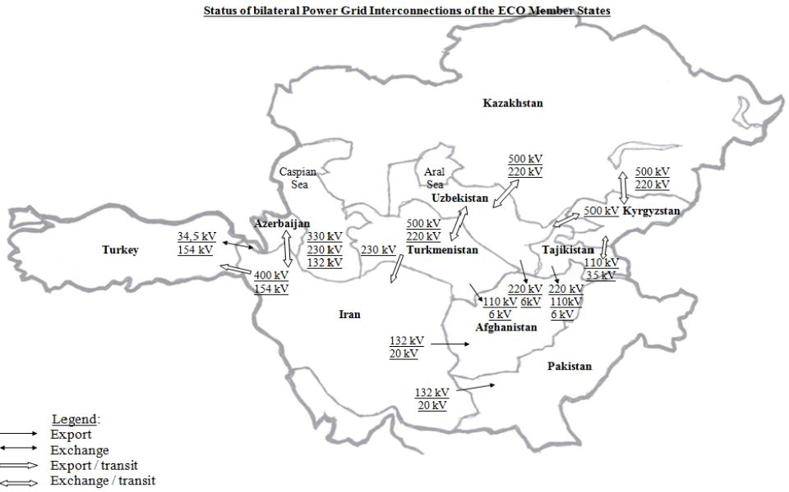

The electricity demand and supply state of affairs in the ECO Region may be divided generally into different groups with each country having potential as a predominantly export, import or transit state.

* Afghanistan is an importing and transit country and has existing interconnections with Iran, Turkmenistan, Uzbekistan and Tajikistan;
* Azerbaijan, Kazakhstan and Uzbekistan are exporting countries with fossil-fuel based generation;
* Iran and Türkiye are both importing and exporting countries;
* Pakistan is an importing country with rapidly growing demand;
* Tajikistan and Kyrgyzstan are exporting countries with hydropower-based generation;
* Turkmenistan is an exporting country.

Regional cooperation requires long-term commitments and remarkable investments in electricity network infrastructure, and depends on both project’s commercial attractiveness and a common level playing field in the region. This cooperation will eventually enhance the economic efficiency of the use of cross-border transmission capacity on seasonal and daily bases and reap financial gains from electricity trade. It will enable complementarities of domestic generating capacities, which might contribute to balancing seasonal inconsistencies. Meanwhile, redistribution of excessive power generation across ECO

Member States might be complemented with more cost-effective investment arrangements for new capacities in these countries. The attractiveness of ECO regional platform would grow, if it can potentially connect two major power markets of EU (and its Energy Community) and the emerging Eurasian region.

Enhancement of regional electricity trade can initially be realized via strengthening intra-regional trade in Central Asia, where an interconnected grid already exists but much needs to be adjusted to ensure adequate supplies of energy and security of supply. By strengthening existing links with Azerbaijan, Iran and Türkiye, the benefits of larger integrated systems can be accessed. Another important advantageous element in interconnecting the power systems of the ECO Member States is the potential of regional power exchange, instead of only as a power export opportunity for the ECO Member States.

***Objectives***

* Promotion of investment climate (macroeconomic grounds, regulatory framework, property rights, etc.);
* Forging certain intergovernmental agreements for specific trade arrangements;
* Building on existing institutional and multi-country agreements in the ECO Region;
* Continuation of strong partnership with the UNESCAP, International Energy Charter and other external entities to support the ECO-REM Project;
* Addressing further cooperation on technical, environmental and regulatory issues.

***Outcome***

Agree on joint actions to implement the ECO-REM project and propose for approval at the next ECO Energy Ministerial Meeting.

**DRAFT AGENDA**

**2nd Experts Group Meeting on establishment of**

**the ECO Regional Electricity Market (ECO-REM)**

1. Inauguration
2. Election of the Chairman
3. Adoption of the Agenda
4. Appointment of the Drafting Committee
5. Statements by the Member States
6. Discussion about the progress of “ECO Regional Electricity Market Project”
7. Electricity market in ECO region. Presentations / Country reports by the Member States (to be focused on recent policies and priorities, capacity for generation, relevant infrastructure and transmission lines, interconnections, promotion of electricity import/export in their respective countries)
8. UNESCAP Presentation on roadmap “Regional Roadmap on Power System Connectivity – ECO Regional Electricity Market: promoting cross-border electricity connectivity for sustainable development”
9. Introductory visit to Nurek HPP
10. Any other business
11. Date and venue of the next meeting
12. Adoption of a Report of the meeting
13. Closing Remarks